**Experiment # 02**

**LCD display with Light and Sound sensors**

Group #: **5**

Members:

**CASAMORIN, Jay**

**CHIU, John Kristian**

**MEDIAVILLIO, Carl Lewis**

**Procedure:**

1. Connect the LCD in your Arduino Uno board. Use the LCD i2c library to drive the LCD in our programming.
2. Connect an LDR (Light dependent resistor) in Arduino uno.
3. First, connect one leg of LDR to one leg of 1K ohms resistor, this connected leg of LDR and 1k ohms should be connected to A0 pin of Arduino uno. The other leg of the LDR should be connected to +5 V of the Arduino board. The other free end leg of the resistor should be connected to GND of the Arduino board.
4. Connect a sound sensor in the Arduino uno. Use the microphone provided in the starter kit.
5. The LCD, the sound sensor and the light sensor should be present in the experiment.
6. Make 3 levels of sound and check the output in the LCD display.
7. Make 3 levels of light intensity and check the result in the LCD display.
8. Record your findings using the analogRead(A0) function.

**CODE: LIGHT**

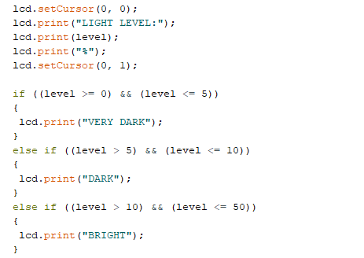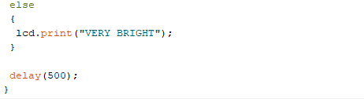

**CODE: SOUND**

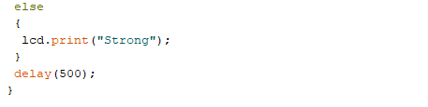

**ILLUSTRATION: LIGHT**

**ILLUSTRATION: SOUND**

**OBSERVATION:**

* Calibration of the potentiometer is hard.
* The coding of the sound measurement is difficult to get.
* Not all pins in the sound sensor is used.
* LCD with I2C needs a different library with just LCD alone.
* Raw data is better than the computed because it properly shows the difference in the loudness of noise.